ANNEXURE D Letter 2 – Template letter from the relevant Regional Office of the DWS / DWS Head office / CMA Office to confirm successful or unsuccessful conclusion of the IWULA Pre-Application Phase
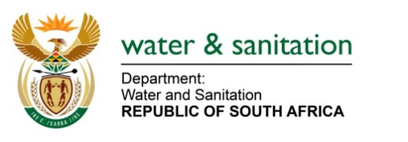

 |  | (012) 336 8947 |  | P/Bag X313
e-mail: |  | enquiry@dwa.gov.za |  | PRETORIA
 |  |  |  | 0001
 |  |  |  | 0001
<insert title>>
<<insert company name>>
<<insert address line1>>
<<insert address line 2>>
<<insert address line 3>>

Attention: <<insert name>

CONFIRMATION OF IWULA PRE-APPLICATION PROCESS

The Department/ CMA hereby confirms the conduct and <<successful/ unsuccessful>> conclusion of the requisite pre-application processes for your water use licence comprising the following:
- submission of the written notice of intent to apply for a water use licence;
- issuance of the letter acknowledging the written notice of intent to apply for a water use licence to the applicant, and the subsequent processes to be followed within the requisite 5 days; and
- the compulsory pre-application processes with the responsible authority, involving meetings and site inspection of facilities of proposed water uses following from the notice of intent to apply, within the requisite 20 days.

Yours faithfully

<<< insert name>>>

<<Provincial Operations Head/ Chief Executive Officer – CMA>>>

